

Frailty Improvement and Implementation Programme

Readiness for Change Assessment & Prioritisation Tool

October 2022



# Contents

Introduction

Section 1: Assessing Organisational Readiness

Section 2: Assessing Team Readiness

Section 3: Understanding Current Practice

Section 4: Prioritising Areas for Improvement

## Introduction

An important first step for organisations and teams in improvement is to assess readiness to implement changes. This document provides a Readiness for Change Assessment tool which will support you to assess how ready your organisation and teams are for change.

## Why Assess Readiness for Change?

A readiness assessment will provide the organisation and team with insights into the challenges and opportunities they may face during the change process - it is critical to ensure that groups can be effectively prepared for a change.

The tool will help you to understand strengths and gaps in your organisation and teams to support your change efforts and to ensure success.

The data collected from the assessment will inform the specific change activities your organisation and teams need to consider. The tool will support you to understand any factors in your organisation and teams that could be barriers or enablers for the change. This is the first step in the process of embedding a high impact change for your organisation and teams.

## How to use the Readiness Assessment

The tool is split into 4 sections:

Section 1: Assessing Organisational Readiness

Section 2: Assessing Team Readiness

Section 3: Understanding Current Practice

Section 4: Prioritising Areas for Improvement.

# Readiness for Change Assessment

## Section 1: Assessing Organisational Readiness

This section should be completed by an identified senior leader within the NHS Board or Health and Social Care Partnership (HSCP) who will provide overall leadership to embedding the learning from developing processes which support people living with or at risk of frailty experience improved access to person centred, co-ordinated health and social care into day to day practice.

Answer each question by scoring it as: **0 – No evidence 1 – Some evidence 2 – Good evidence**

|  |  |
| --- | --- |
| **Board/HSCP Level Questions** | **Evidence Score (0-2)** |
| There is executive commitment to embedding the learning from developing processes which support people living with or at risk of frailty experience improved access to person centred, co-ordinated health and social care. |  |
| There is an identified senior leader within the board/HSCP who will provide overall leadership to embedding the learning from developing processes which support people living with or at risk of frailty experience improved access to person centred, co-ordinated health and social care into day to day practice. |  |
| The board/HSCP is committed to providing resources and time to work on embedding processes which support people living with or at risk of frailty experience improved access to person centred, co-ordinated health and social care. |  |
| The board/HSCP provides teams with access to leaders who can support changes and improvements in practice. |  |
| The board/HSCP provides education, training and support to enable staff to take forward changes in practice. |  |
| The board/HSCP has mechanisms to capture, collate and use data to support improvement. |  |

|  |  |
| --- | --- |
| **Total score (Board/HSCP questions):** |  |
| **Comments:** | |

## Assessing Organisational Readiness – understanding your score

* Organisations which score less than 7 in this section are recommended to undertake further preparation work before commencing improvement work.
* Organisations which score between 7 and 13 in this section may need to undertake minor preparation before commencing improvement work but are nearly ready.
* Organisations scoring 14 in the organisation assessment are ready to start improvement work and should be mindful of any areas that may require attention.

Note: Organisations scoring 13 or below should be aware that these wider elements of organisational readiness may take some time to be addressed. This means that improvement work can be commenced – however it should run in parallel to the work being undertaken at organisational level.

Additional support may be available to you within your organisation, and you can use the following links to learn more:

[*Achieving sustainable change (NHS Education for Scotland)*](https://learn.nes.nhs.scot/33853/human-factors/organisational-learning/achieving-sustainable-change)

[*Measuring safety culture (The Health Foundation)*](https://www.health.org.uk/sites/default/files/MeasuringSafetyCulture.pdf)

[*Self-evaluation tool (Care Inspectorate)*](https://www.careinspectorate.com/images/documents/5916/Self-eval%20tool%20&%20guide%20Q7%20COVID-19.pdf)

[*The improvement journey (The Health Foundation)*](http://www.health.org.uk/publications/reports/the-improvement-journey)

## Section 2: Assessing Team Readiness

This section should be completed by a manager / team lead within the organisation who will have operational responsibility for embedding the identification of, and learning from cardiac arrests into day to day practice.

Answer each question by scoring it as: **0 – No evidence 1 – Some evidence 2 – Good evidence**

|  |  |
| --- | --- |
| **Team Level Questions** | **Evidence Score (0-2)** |
| At least one member of the team is a senior decision maker who can influence changes to processes which support people living with or at risk of frailty experience improved access to person centred, co-ordinated health and social care. |  |
| Team members report experience of working well together, for example via one-to-one discussions, supervision conversations or in team meetings. |  |
| The team uses processes and tools to enhance communication. |  |
| The team has decision-making processes in place with clarity of roles, responsibilities and routes of escalation. |  |
| The team has a shared understanding of the benefits of developing processes which support people living with or at risk of frailty experience improved access to person centred, co-ordinated health and social care. |  |
| The team have skills and experience to make changes and improvements in practice. |  |
| The team is committed to achieving shared goals. |  |
| The team aims are directly aligned with the organisation's key strategic goals. |  |

|  |  |
| --- | --- |
| **Total score (Team questions):** |  |
| **Comments:** | |

## Assessing Team Readiness – Understanding your team score

## The total score listed below should be used to inform your next steps:

* Teams which score less than 8 in the team assessment are recommended to undertake further preparation work before commencing improvement work.
* Teams which score between 8 and 15 in the team assessment may need to focus on particular areas before commencing improvement work but are nearly ready.
* Teams scoring 16 in the team assessment are ready to start improvement work and should be mindful of areas that may require some attention.

Note: Teams scoring 15 or below should be aware that these wider elements of team readiness may take some time to be addressed. This means that improvement work can be commenced – however it should run in parallel to the work being undertaken at team level.

Additional support may be available to you within your organisation, and you can use the following links to learn more:

[*The improvement journey - creating the conditions (NHS Education for Scotland)*](https://learn.nes.nhs.scot/820/quality-improvement-zone/improvement-journey/create-conditions)

[*How we support improvement (Care Inspectorate)*](https://hub.careinspectorate.com/how-we-support-improvement/)

[*Quality improvement made simple (The Health Foundation)*](https://www.health.org.uk/publications/quality-improvement-made-simple)

[*Using communications approaches to spread improvement (The Health Foundation)*](https://www.health.org.uk/publications/using-communications-approaches-to-spread-improvement)

## Section 3: Understanding current practice

Once you have completed sections 1 and 2 and established how you will undertake and align any organisational / team readiness development, you are ready to progress with work to improve the experience and access to person centered, coordinated health and social care for people living with or at risk of frailty.

This section will support you to understand and develop your approach to embedding work to improve the experience and access to person centered, coordinated health and social care for people living with or at risk of frailty, into your day to day work, by helping you to understand your current practice.

* Use the scale to describe how well you have each secondary driver embedded into day to day practice.
* Record any data sources that you can use to provide evidence / assurance.

|  |  |  |  |  |  |
| --- | --- | --- | --- | --- | --- |
| **Improving the experience of, and access to person centered, coordinated health and social care services for people living with or at risk of frailty** | |  | | **DATA SOURCE (EVIDENCE)** | |
| **Early identification and assessment of frailty** | | | | |
| Use of reliable tools and shared language to identify frailty and those at risk of frailty |  | |  | |
| Timely delivery of Comprehensive Geriatric Assessment |  | |  | |
| Proactive reassessment and responsive multidisciplinary and multi-agency intervention |  | |  | |
| **People living with frailty, carers and family members access person centered health and social care services** | | | | |
| Resources, services, and community assets which support prevention and empower people to self-manage |  | |  | |
| Proactive person-centred care planning, management and end of life care |  | |  | |
| Timely and equitable access to clearly defined care pathways |  | |  | |
| Effective care co-ordination to improve experience of care |  | |  | |
| Health and social care services are responsive to changes in an individual’s level of frailty |  | |  | |
| **Leadership and culture to support integrated working** | | | | |
| Strategic leadership which supports integrated working |  | |  | |
| Integrated multidisciplinary and multi-agency working |  | |  | |
| Co-producing services with people, families and carers with lived experience |  | |  | |
| Compassionate leadership to promote psychological safety and staff wellbeing |  | |  | |
| System for learning |  | |  | |

|  |
| --- |
| **Comments:** |

## Section 4: Prioritising areas for improvement

Once you have completed section 3 to establish what you already have embedded and any gaps in practice, you are ready to identify your priorities for improvement. This section will support you to understand how to balance effort and impact, either as part of continuous improvement of current practice, or of the introduction of new ways of working.

Using what you have learned in section 3 about your current practice:

* have a discussion with your team and create a list of improvements you would like to make;
* consider the potential impact, and the level of difficulty, of making these improvements;
* arrange them on the matrix below as a guide;
* identify your first area of focus for improvement;
* develop your improvement plan.

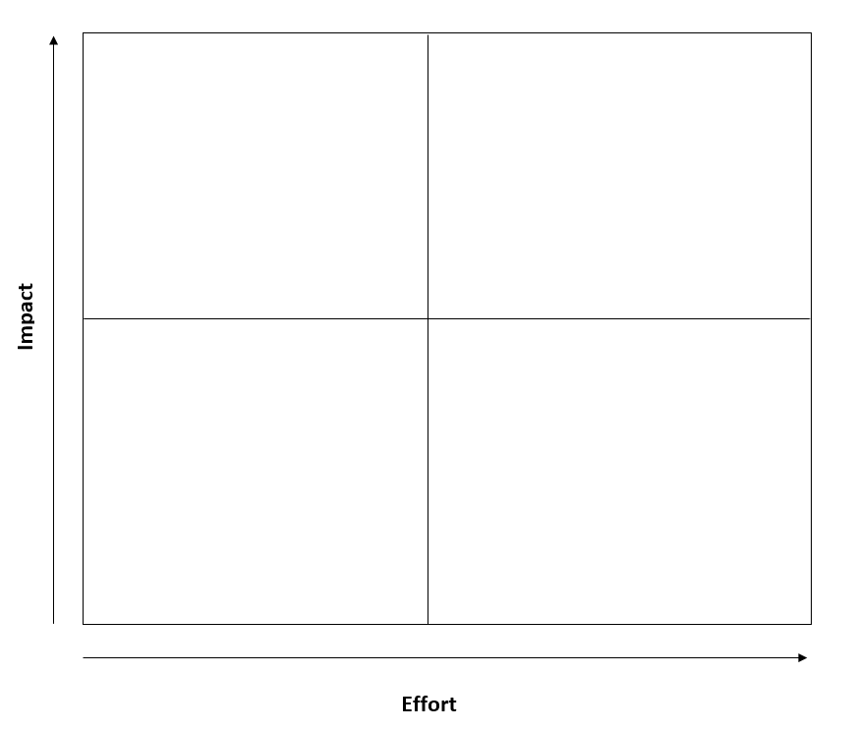

Once this process is complete you will see your priorities sitting towards the upper half of the matrix.

Items on the top left are your “quick wins” – lower effort, high impact ideas. As you move across to the right the ideas require more effort.

Don’t try to do too much from the top-right of the matrix.

Review the matrix regularly. You should be continuously learning from your testing and this may mean changes to your priorities.

You can download a blank template [here](https://learn.nes.nhs.scot/3983/quality-improvement-zone/qi-tools/prioritisation-matrix/prioritisation-matrix).

Published October 2022

You can read and download this document from our website.   
We are happy to consider requests for other languages or formats.   
Please contact our Equality and Diversity Advisor on 0141 225 6999   
or email his.contactpublicinvolvement@nhs.scot

Published September 2022

You can read and download this document from our website.   
We are happy to consider requests for other languages or formats.   
Please contact our Equality and Diversity Advisor on 0141 225 6999   
or email contactpublicinvolvement.his@nhs.net

Healthcare Improvement Scotland   
Scottish Health Technologies Group

|  |  |
| --- | --- |
| Edinburgh Office Gyle Square 1 South Gyle Crescent Edinburgh EH12 9EB  0131 623 4300 | Glasgow Office Delta House 50 West Nile Street Glasgow G1 2NP  0141 225 6999 |

www.healthcareimprovementscotland.org