

Essential Future Care Planning Guidance and Template

Version 4, published November 2023

# Having Future Care Planning conversations

# Some people may be worried about the future, and so it can be reassuring and helpful for them to discuss these concerns with a health professional. [Future care planning](https://ihub.scot/project-toolkits/future-care-planning-toolkit/future-care-planning-toolkit/tools-and-resources/) is a ‘thinking ahead’ approach, based around a conversation about ‘What Matters to You’. It provides people with the opportunity to consider and discuss the types of treatment and care that would or would not be acceptable to them, should they become unwell. Together with a health professional from the multidisciplinary team, it is possible to plan the types of intervention, treatments and care that would be right for that individual. The approach has an individual’s most important values at its heart and is grounded in human rights.

These future care planning conversations should take place and evolve over time. People should have the opportunity to involve family members and any power of attorneys in these discussions.

These discussions can be extremely difficult to start, but they are important and helpful. The aim is to have an open and honest conversation with people and their families and carers so that we can plan future care as well as possible. There are many different forms and templates that facilitate the documentation and sharing of this information. This ‘[Essential Future Care Plan](https://ihub.scot/project-toolkits/future-care-planning-toolkit/future-care-planning-toolkit/tools-and-resources/documentation-and-sharing/essential-future-care-plan/)’ is a simple 1-page document that can be used to capture the key components of a future care plan.

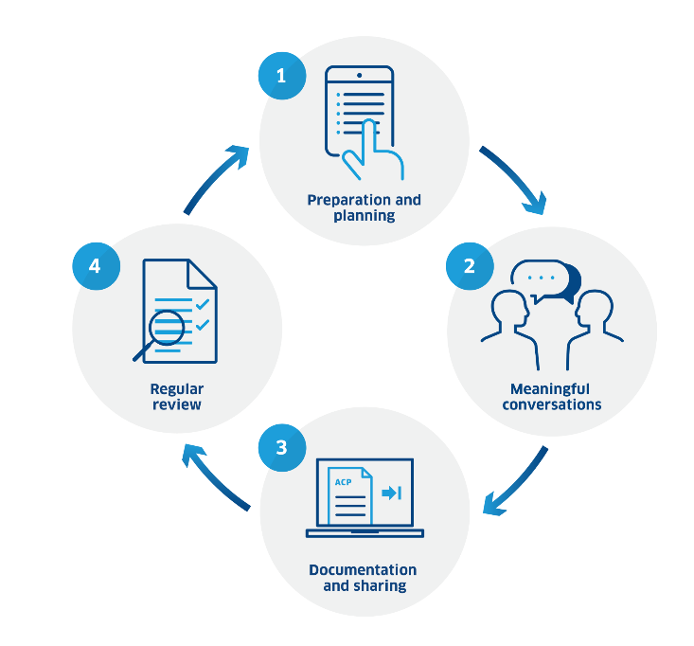Healthcare Improvement Scotland recommends a 4-step approach to future care planning which can be found [here](https://ihub.scot/project-toolkits/future-care-planning-toolkit/future-care-planning-toolkit/tools-and-resources/):

No-one should be forced to have these conversations, or to have a future care plan. Some people may not be ready, and it may be necessary to revisit this topic at another time. NHS Inform have prepared a [guide](https://www.nhsinform.scot/care-support-and-rights/decisions-about-care/future-care-planning/) which some patients and carers may find helpful.

To give feedback on the Essential Future Care Plan please email his.pcpteam@nhs.scot.

Essential Future Care Plan

|  |  |  |  |
| --- | --- | --- | --- |
| **Name** |  | **Preferred name** |  |
| **CHI or DoB** |  | **Phone number** |  |
| **Address** |  | | |

|  |  |
| --- | --- |
| **Ask:** 'If you were to become seriously unwell due to a deterioration in your health, how would you like to be cared for?  **Ask:** 'Is there anyone that you would like to be involved in future decisions about your care, if you were to become unwell (for example, a friend, family member or carer)?  **Note:** Ensure that the person is ready to have this conversation and has the opportunity to involve others (for example, family members or any power of attorney). | |
| **The things you would like:** | |
| **The things you do not want:** | |
| **Any other information around preferences for care:** | |
| **Discussions about cardiopulmonary resuscitation:** (Document if a red DNACPR form or a ReSPECT form has been completed, and where it is held). | |
| **The people you would like to be involved in decisions about your care:**(List names, contact info and whether any have [power of attorney](https://ihub.scot/media/1497/acp-things-to-think-about-1-0.pdf) or welfare guardianship). | |
| **Other important contacts** (for example, next of kin / carer / neighbour): | |
| **Key worker** (for example, social / health care / mental health worker): | |
| **Name and contact details of responsible clinician** (for example, consultant / GP/ other): | |
| **Name and designation of person who has led this discussion:** | **Date completed**: |
| **Email address and telephone number:** | |
| **Consent obtained to share in Key Information Summary** (good practice but not mandatory)Yes  No **Please send the completed document to the person’s GP practice so that the above information can be included in the Key Information Summary. Remember that the information contained in this form is private and confidential and must be handled in compliance with General Data Protection Regulation (GDPR).** | |

**Published November 2023**

by-nc-nd

This document is licensed under the Creative Commons Attribution-Non-commercial-NoDerivatives 4.0 International Licence. This allows for the copy and redistribution of this document as long as Healthcare Improvement Scotland is fully acknowledged and given credit. The material must not be remixed, transformed or built upon in any way. To view a copy of this licence, visit <https://creativecommons.org/licenses/by-nc-nd/4.0/>

You can read and download this document from our website.   
We are happy to consider requests for other languages or formats.   
Please contact our Equality and Diversity Advisor on 0141 225 6999   
or email [his.contactpublicinvolvement@nhs.scot](mailto:his.contactpublicinvolvement@nhs.scot)

Healthcare Improvement Scotland

Edinburgh Office  
Gyle Square  
1 South Gyle Crescent  
Edinburgh  
EH12 9EB  
0131 623 4300

[www.healthcareimprovementscotland.org](http://www.healthcareimprovementscotland.org)