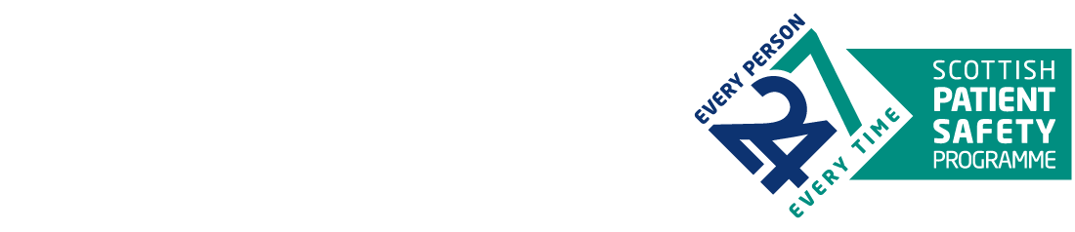

SPSP Acute Adult

Structured Response to Deterioration

Mapping Tool

The SPSP Acute Adult programme have co-designed principles for a structured response to deterioration with clinicians from across Scotland. The principles have been developed to support existing local processes in place to respond to deteriorating patients. This mapping tool offers teams a mechanism to consider their current practice to identify areas of strength, and opportunities for improvement.

# **What you will need**

To make the mapping relevant to your clinical context we encourage teams to choose a patient case, which will explore the recognition, response, review and reassessment to a deteriorating patient. You may wish to draw on current themes from your morbidity and mortality reviews or incident reporting.

# **Team to undertake the mapping**

It is important to include a range of staff from a clinical team plus a colleague with quality improvement expertise. You may wish to invite up to five colleagues from a range of roles, one of whom should be a senior decision maker.

* Medical staff
  + Junior doctors
  + Middle grade
  + Consultant
  + Consultant(s) from clinical area deteriorating patients are most commonly escalated and referred to, such as critical care
* Nursing staff
  + Advanced Nurse Practitioner (ward)
  + Advanced Nurse Practitioner from hospital wide service
  + Staff nurses (mix of experience)
  + Senior charge nurse
  + Healthcare support workers
* Any other professions or specialties which are pertinent to the care of the case under discussion, such as resuscitation officer, radiology, on-call physiotherapy

# **Participants**

|  |  |
| --- | --- |
|  |  |
|  |  |
|  |  |
|  |  |
|  |  |
|  |  |
|  |  |
|  |  |
|  |  |
|  |  |
|  |  |
|  |  |
|  |  |

# **Using the Mapping Tool**

1. Facilitated session running through the clinical case from recognition to reassessment
2. Identify three steps in the process the team consider have most scope for improvement
3. Focusing on the three steps identified explore what makes them more challenging, and workarounds already in use.

|  |  |  |  |  |
| --- | --- | --- | --- | --- |
|  | **Principle and Prompts** | **What we currently do and who usually does it**  Walk through what usually happens in the ward or clinical area for each principle | **Works Well** | **Potential for Improvement** |
| **Recognition** | How do you recognise deterioration in your area?   * NEWS2 * Clinical concern * Patient, family or carer concern * Locally agreed trigger(s) |  |  |  |
| What is the process for escalation through the team?   * Are there particular times of day/days of the week where it is easier or more difficult? * When would you call the [*insert any local teams e.g. outreach*]? |  |  |  |
| **Response & Review (A to E) EE)Assessment)** | Identifying a working diagnosis |  |  |  |
| What processes are in place to establish a patient’s wishes (use of future care planning/TEP) and how reliably accessed/completed are these? |  |  |  |
| Can you reliably access the investigations you most often require? (consider differences in time of day / weekend) |  |  |  |
| What is the process to seek consultant review?  How easy is it for you to access critical care support? |  |  |  |

|  |  |  |  |  |
| --- | --- | --- | --- | --- |
|  | **Principle** | **What we currently do and who usually does it** | **Works Well** | **Potential for Improvement** |
| **Response & Review (A to E) EE)Assessment)** | Developing a management plan |  |  |  |
| Are observation frequency plans appropriate, and feasible for clinical area? |  |  |  |
| What is the process for prompting reassessment – criteria, timeframe, other? |  |  |  |
| Triage Decision – considerations about best location for the patient |  |  |  |
| **Reassess** | How do you identify whether patient is still of concern? |  |  |  |
| When reviewing progress since initial response, how easy is it for the team to reconsider:   * Working diagnosis * Management plan in light of progress * TEP / future care plan or ACP * Triage decision |  |  |  |
| What is the process for prompting further reassessment |  |  |  |

# **Next Steps**

**Prioritising identified topics**

Please populate the table below with the potential opportunities for improvement identified in your conversation above.

The prioritisation table below can help inform your conversations about which QI project should be progressed next.

|  |  |  |  |
| --- | --- | --- | --- |
| Potential QI projects | **Potential Impact**  **(0-10)** | **Effort**  **(0-10)** | **Priority Score =**  **Impact – Effort** |
| Example topic: Reduce time from recognition to review | 6 | 3 | **3** |
|  |  |  |  |
|  |  |  |  |
|  |  |  |  |
|  |  |  |  |
|  |  |  |  |
|  |  |  |  |

**Where to start**

Your local QI team may be a good first point of contact for support in planning where to focus first.

Agreed Next Steps:

Mapping tool adapted from: Human Performance Oil and Gas (2020) [Walk Through Talk Through Template](https://www.hpog.org/resource-centre/wttt/walk-through-talk-through-template/)